IBM CLOUD SERVICE

K.SRIRANJANI’S ACCOUNT

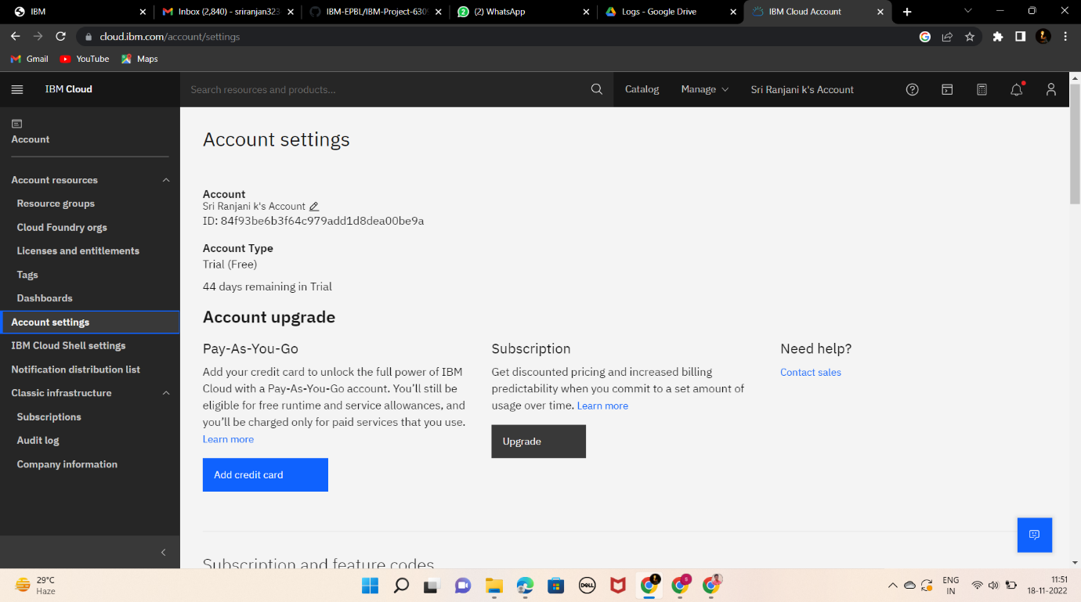

PR SOWNDHARIYA’S ACCOUNT

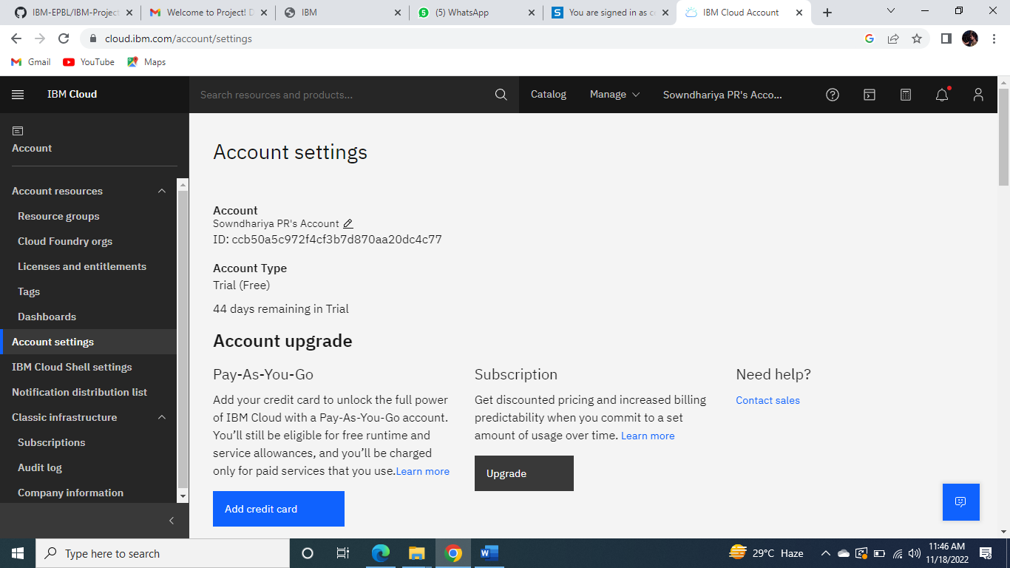

S.UTHRA’S ACCOUNT

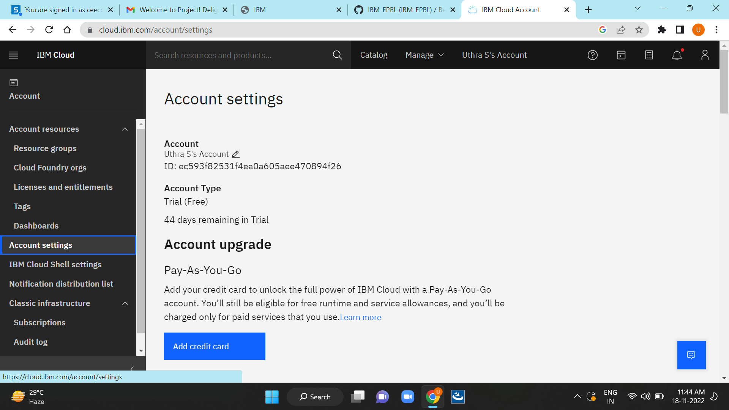

E SWARNA’S ACCOUNT

